**Launched and connected to Linux EC2 instance. Find the below snips for your reference:**

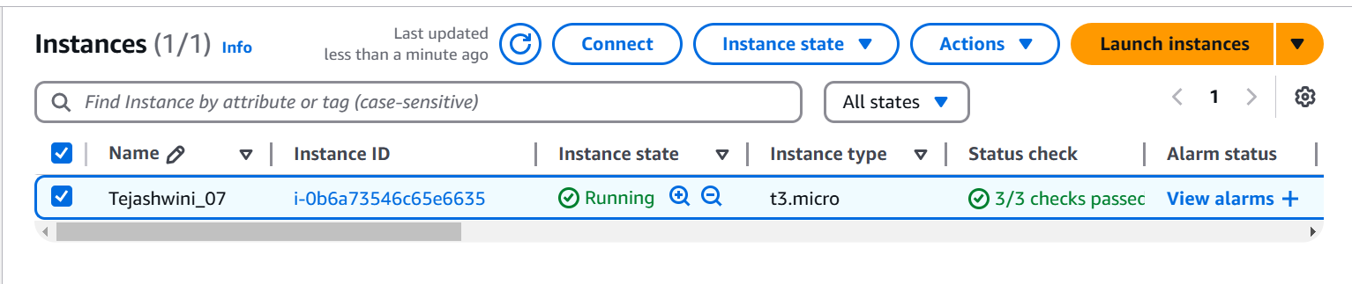

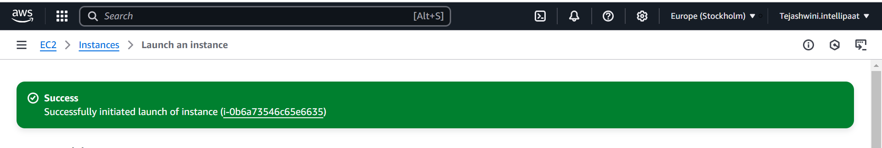

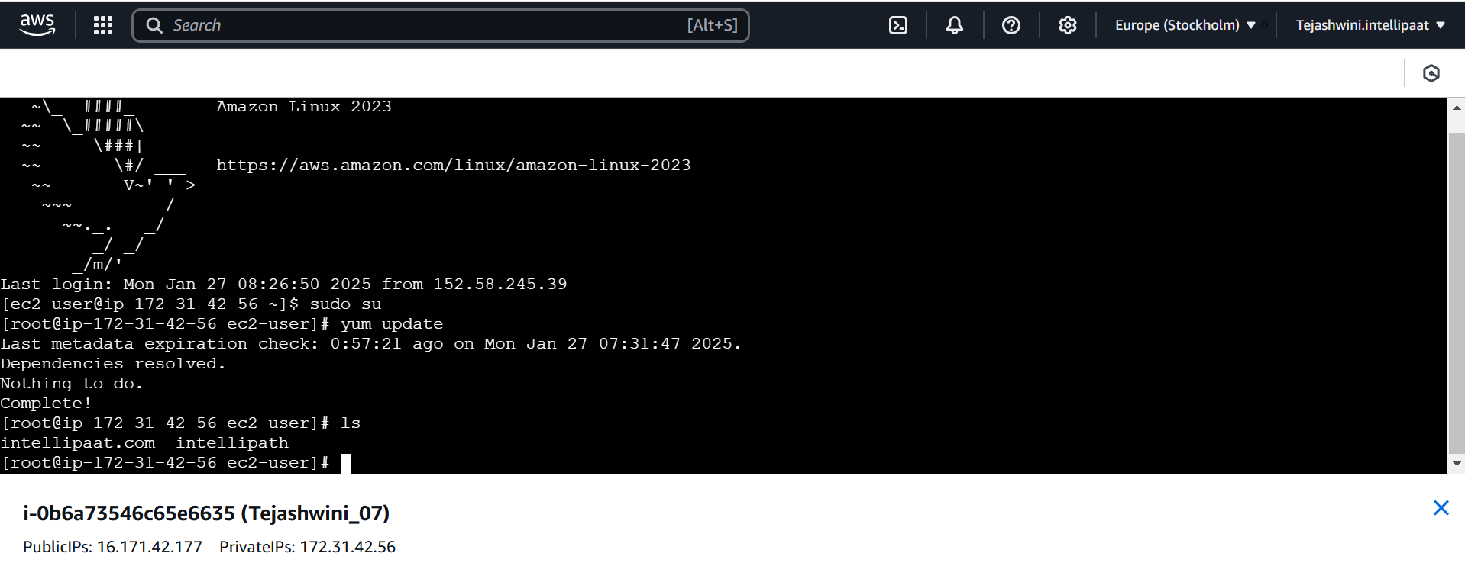

**Other method to connect EC2 using SSH from the command prompt:**

**Step 1: Copy the Public IPv4 address**

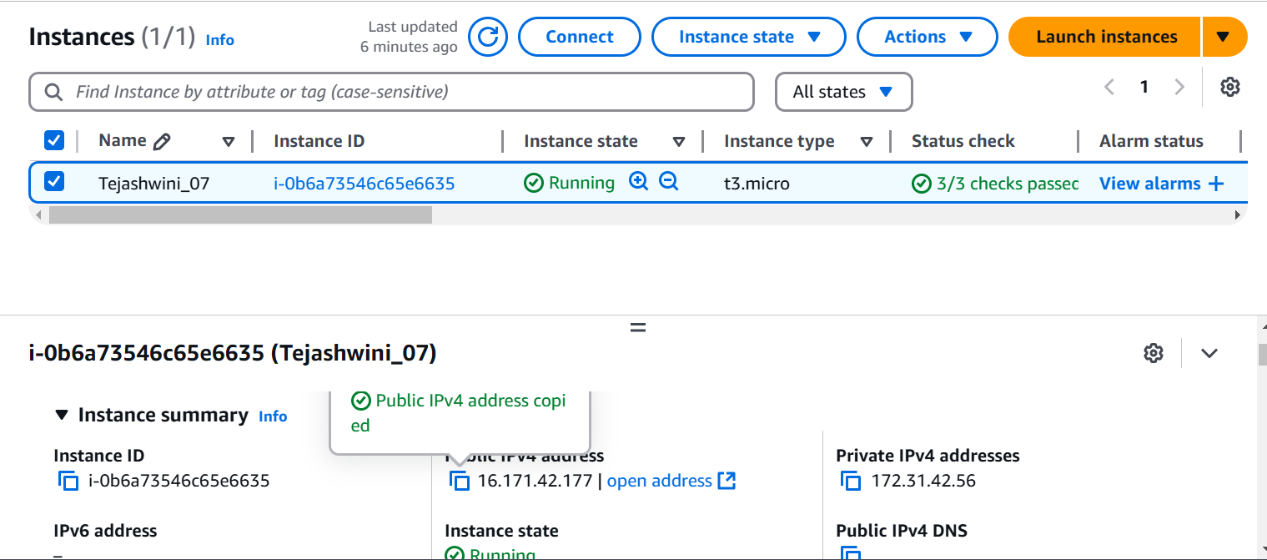

**Step 2: Open the command prompt**

